**FLOWCHART**

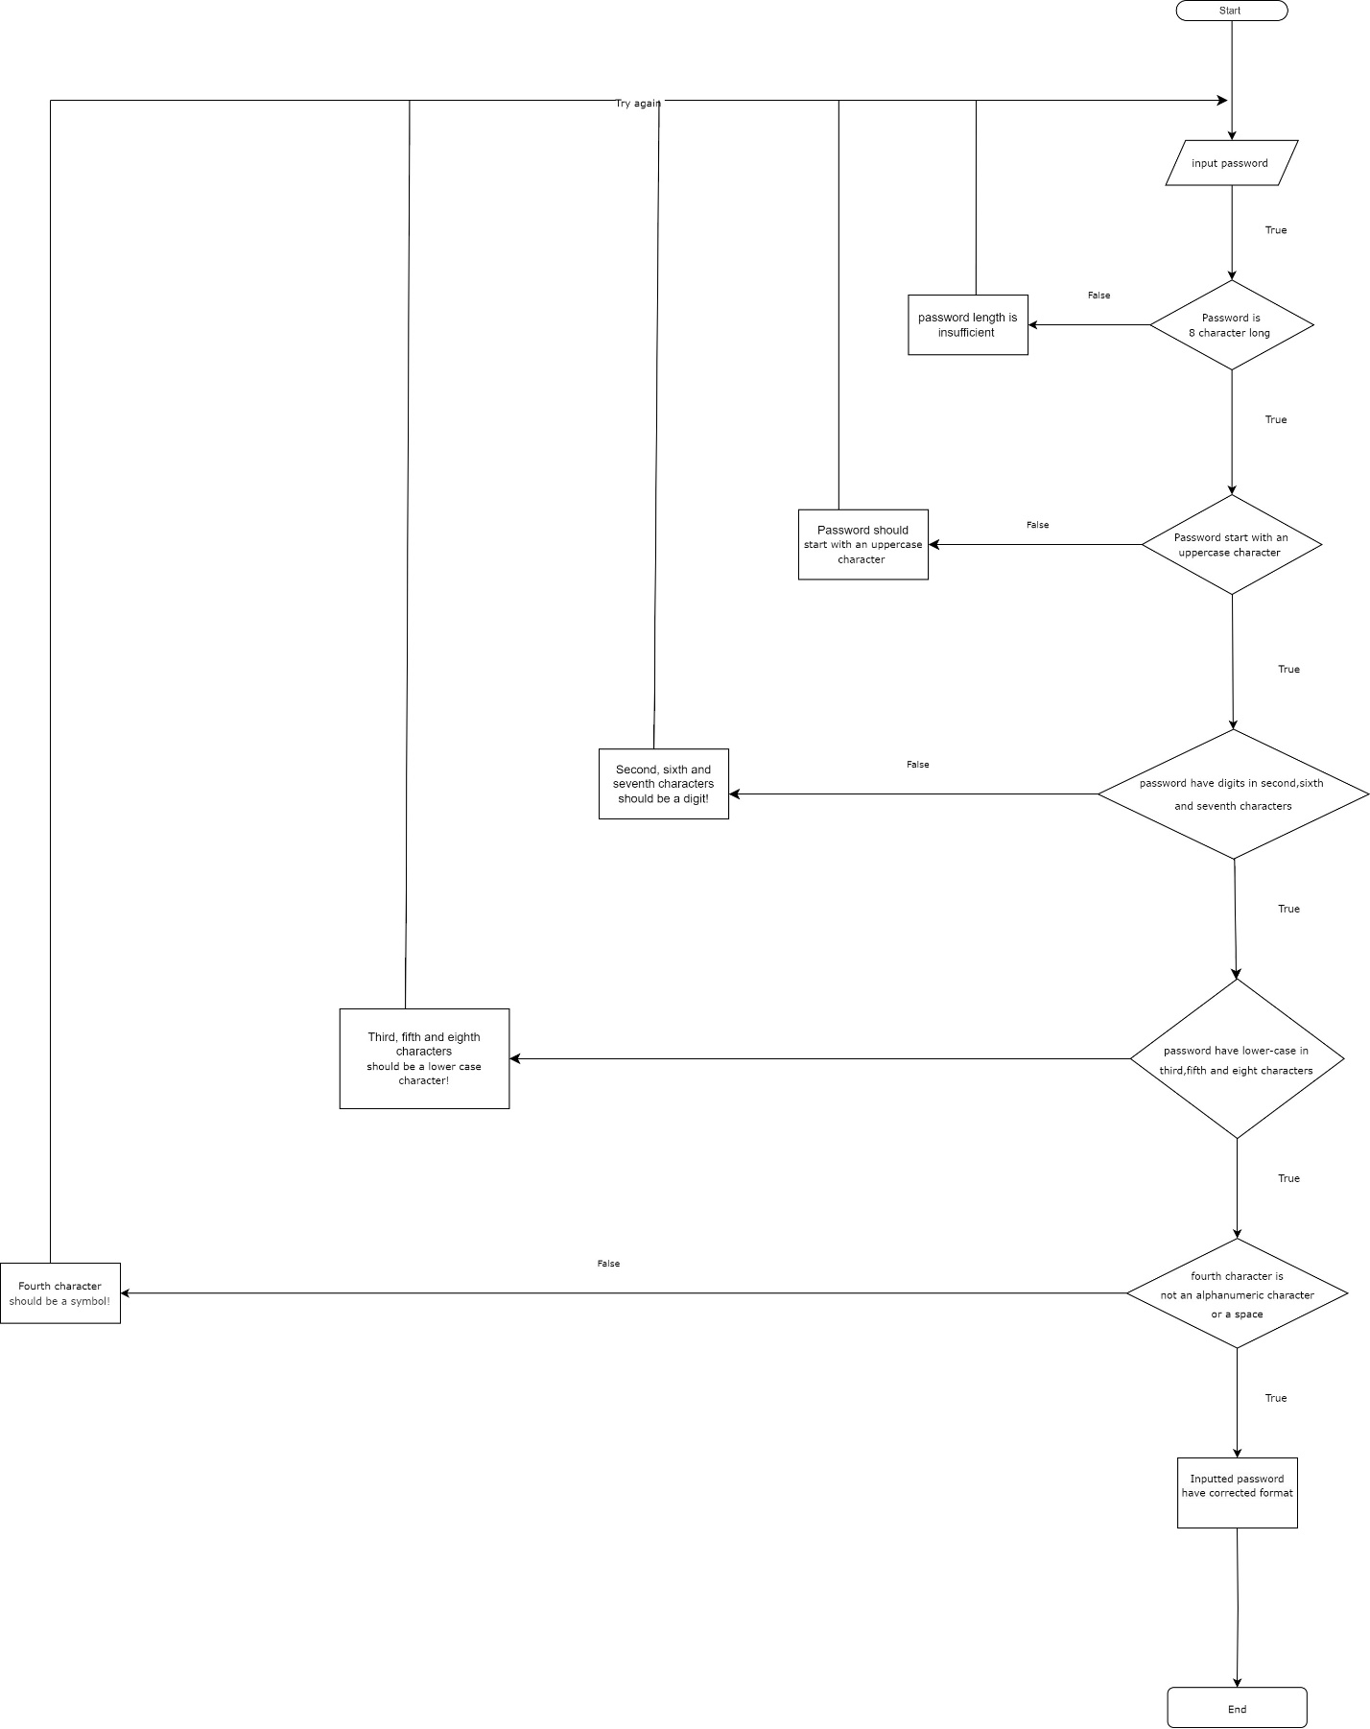

**PSUEDOCODE**

START

Declare Upper as int

Declare Lower as int

Declare digit as int

Declare symbol as int

Declare int x = 1 as a Boolean value where x is true

Declare password as char with size of 10 characters

Prompt user to input a password

Print enter password that have similar format to L5e$e55e:

Input password

If password length is less than 8 characters

{

Then print password have insufficient length!

x = 0 (false)

End if

}

For i from 0 to the length of password - 1

{

If password start with a upper case character

Then increase Upper by 1

End if

End for

}

If Upper <1

{

Then Print "Password should start with an uppercase character!"

x = 0

End if

}

For i from 0 to the length of password – 1

{

If password have 3 digits in second, sixth and seventh characters

Then increase digit by 1

End if

End for

}

If digit < 3

{

Then print "Second,sixth and seventh characters should be a digit!”

x = 0

End if

}

For i from 0 to the length of password - 1

{

If password have lower-case in third,fifth and eight characters

Then increase Lower by 1

End if

End for

}

If Lower <3

{

Then print " Third,fifth and eighth characters should be a lower case character!”

x = 0

End if

}

For i from 0 to the length of password - 1

{

If fourth character is not an alphanumeric character or a space

Then Increment Symbol by 1

End if

End for

}

If there is less than 1 symbol in password

{

Then Print “Fourth character should be a symbol!"

x = 0

End if

}

If x is true and all conditions have been met

Then print “Inputted password have corrected format"

End if

return 0

**CODE EXPLAINATION**

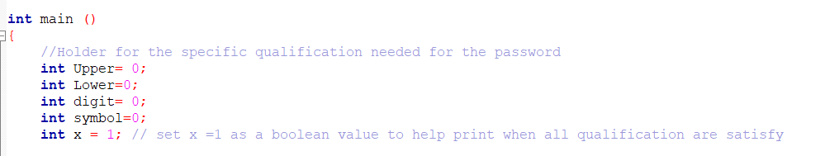

* I start off with naming and declaring the necessary variable for the code. While other variables is set as 0 to hold value, x is initialize to be equal to 1 as a Boolean value, it while equal to 0 when all the conditions aren’t met and will only print out the message if all conditions are met.

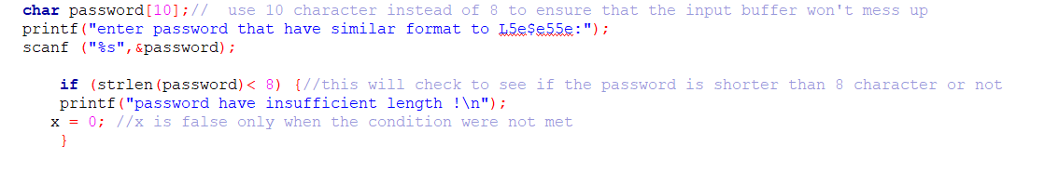

* Password is set as a character array which hold 10 character since it only require ú to input a password with 8 characters and it will also help prevent the program from crash.
* Now the compiler will print out a message to inform the user to input a password that have a familiar format to the one that was given.
* If inputted password is less than 8 words, the compiler will print out an error message and set the x value to 0 and end the program.



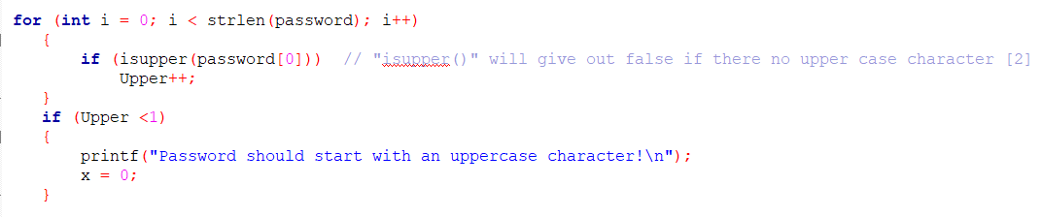

* If the inputted password have 8 characters, the compiler will move to the next test which it will check for upper case character in the password.
* By utilizing “isupper” we can check to see if the first character (position 0 in password array) is an upper case character or not. If it founded a upper case character in the beginning it will increase the Upper value by one and move on to the next test.
* If Upper is smaller then 1 then it will print out the error message and break the program with x =0.



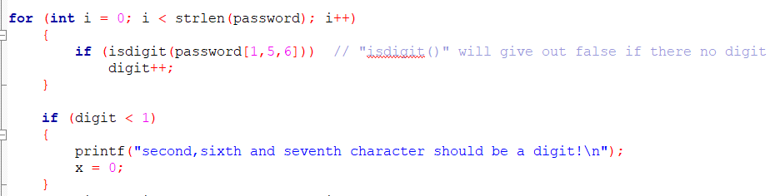

* For checking digit in password we use the same code structure as above, we use “isdigit” check for number in second, sixth and seventh character in array location 1,5 and 6. It will print out the error message if Digit smaller than 1 and set x = 0 .



* The same princilble apply for checking lowercase characters with “islower”

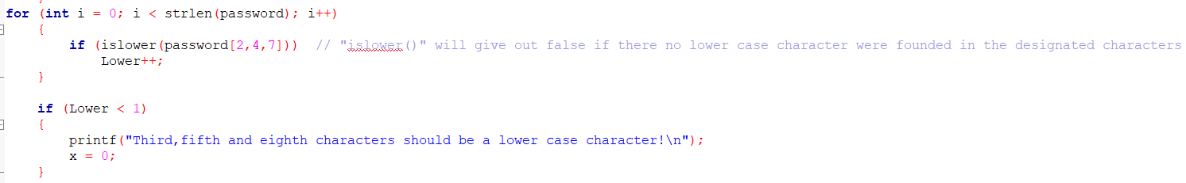



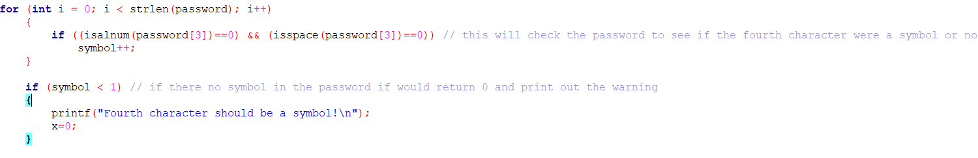

* For checking symbol in the fourth character since there is no function call “issymbol” to check for it we have to check it using “isalnum” and “isspace”. This two function will check to see if there any letter, number or space in the fourth character or not.
* If they doesn’t detect any letter, number or space in the fourth character then is will increases symbol holder by 1 and move on to the next line of code, if is found any then it won’t increase symbol holder and print out the error message.



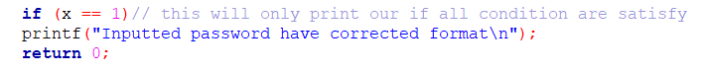

* If all conditions are satisfies then x is set to be true and it will print ou the message saying that the inputted password is correct.

**RESULT**



**REFERENCE**

* “Why Statement Doesn’t Show up When Input?” Stack Overflow, stackoverflow.com/questions/77380612/why-statement-doesnt-show-up-when-input?answertab=createdasc&newreg=d868225c95114bfdae92bb952702df26.(Accessed 12 Nov. 2023).
* GeeksforGeeks. (2017). isupper() function in C Language. [online] Available at: https://www.geeksforgeeks.org/isupper-function-c-language/.

Accessed 12 Nov. 2023.